Arctic mosquitoes Feb 2018

**Questions and Hypotheses**

Overarching question: What determines the number and size of mosquitoes emerging from ponds?

Some possibilities:

1. Females oviposit in habitats that have a high probability of survival for their offspring. For example, the edges of dried ponds that are likely to be wet the following year. **Ponds with more eggs have more larval mosquitoes and have the largest number of emerging adults, furthermore those adults are the largest.**

This seems very likely, given the data I have so far. The ponds with the most larvae tend to have the largest number of emerging mosquitoes. Moreover, those places seem to have higher growth rates and larger mosquitoes (not always, but often).

1. Ponds vary in the density of early instar mosquitoes. **Ponds with higher densities of early instar mosquitoes have greater per-capita mortality due to competition, and have about the same number of emerging mosquitoes as ponds with lower densities of early instars.**

I see some evidence of negative density dependence in ponds, especially when looking across the same ponds in different years. But it still seems that there is undercompensation in most cases (more mosquitoes = more mosquitoes).

1. Ponds vary in terms of the quality and quantity of food for mosquitoes (microorganisms on detritus and vegetation). **Ponds with more mosquito food have larger emerging adults, furthermore resource competition is alleviated in ponds with more food (less or no density dependent mortality)**

I have basically no data to answer this at the moment, but I think it is really important, and should be a focus of the 2018 field season.

1. Ponds vary in aquatic predator density. **More mosquitoes emerge in ponds with less predators.**

Given the data I have so far, I don’t see strong evidence for this.

1. Some ponds are warmer than others, affecting mosquito development time. **More mosquitoes emerge from warmer sites because they grow faster, and have less days to experience mortality from predators.**

Temperature seems to play a role in average growth rates, but does not seem to be correlated with higher survival (from what I can tell so far)

**DENSITIES**

1. **Are the places with the most # larval mosquitoes consistent across years?** 
   * Avg number of early instar mosquitoes (1st sampling date at ponds)

**Maybe. But 2012 lowest abundance in all cases.**

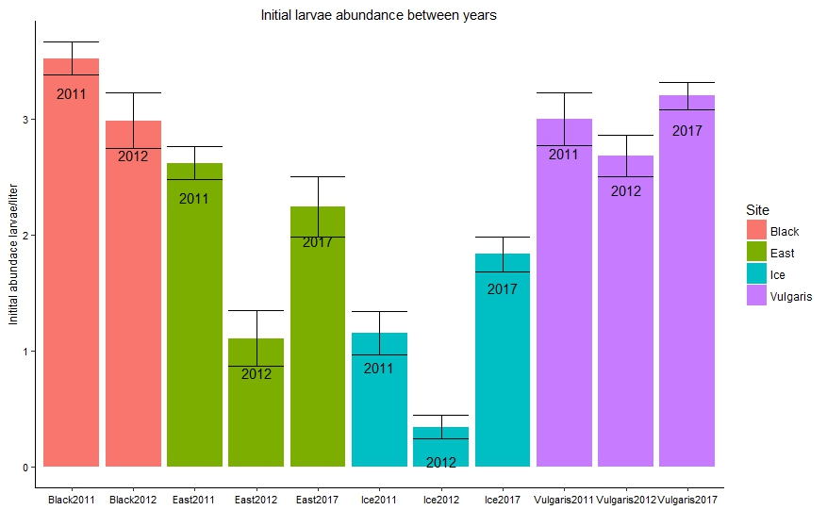

1. **Are the places with the most # of pupae consistent across years?**

**No. Variation between years and between ponds.**

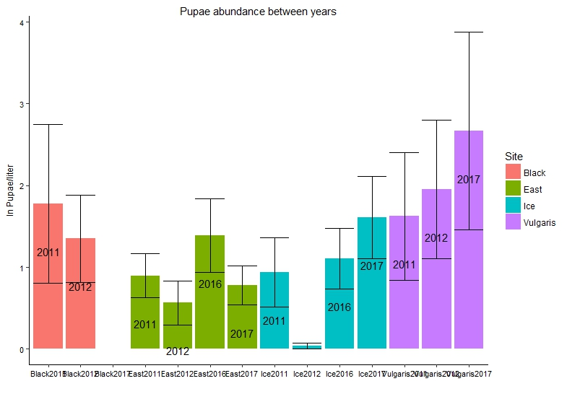

1. **Do ponds with more early instar mosquitoes have more pupae?**

**Yes. More early instars = more pupae = more emerging adults**

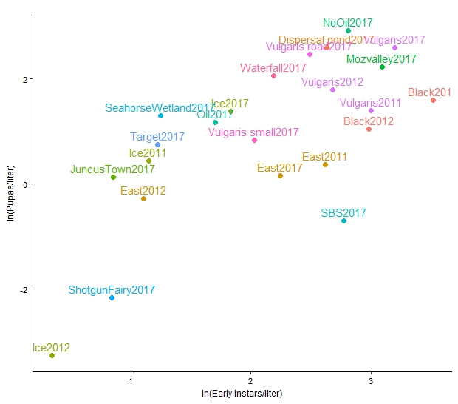

1. **Do ponds with greater densities of early instars have smaller emerging mosquitoes?**

**No it’s the opposite…when there’s more larval mosquitoes they are bigger**

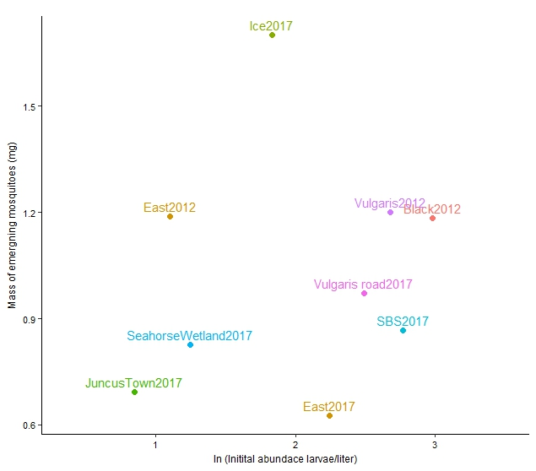

1. **Do ponds with higher densities of larvae have higher per-capita mortality?**

**How does per capita mortality change across years?**

Within the same ponds (looking across years) steeper slopes seem to be correlated with higher initial densities. BUT this doesn’t hold in comparing across ponds exactly. For example, Black and East have higher per capita mortality than Vulgaris even though initial densities are comparable.

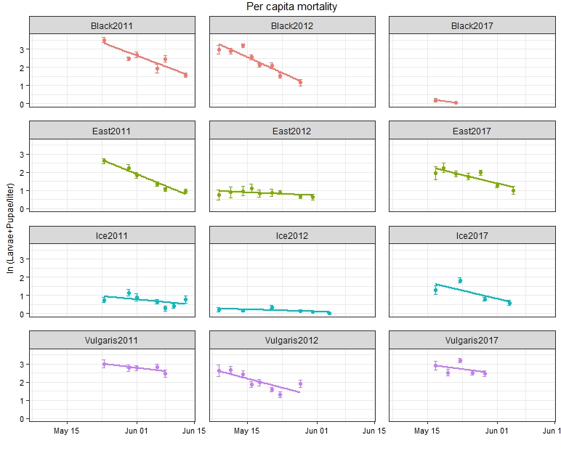

1. **Do ponds with higher densities of larvae have higher per-capita mortality?**

I extracted the slopes from the above figure (+11 other ponds I have same data for). I regressed slope (per capita mortality) vs. the number of mosquitoes in the pond on the 1st sampling date (not exactly N(0) but my best estimate for now)

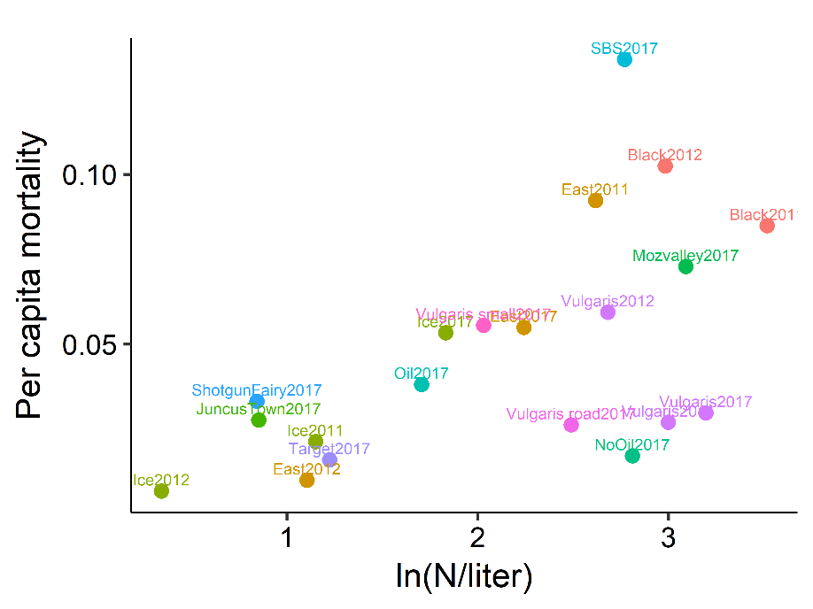

**DENSITIES/GROWTH RATES**

1. **Do ponds with higher densities of larvae have slower relative growth rate?**

**(Just an example of how the mass data look…notice they are quite linear)**

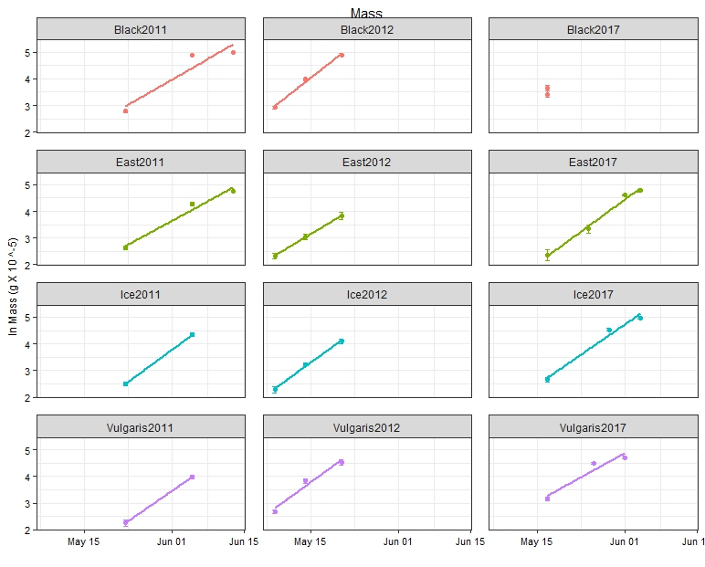

**No. Where there are more individuals they seem to grow MORE**

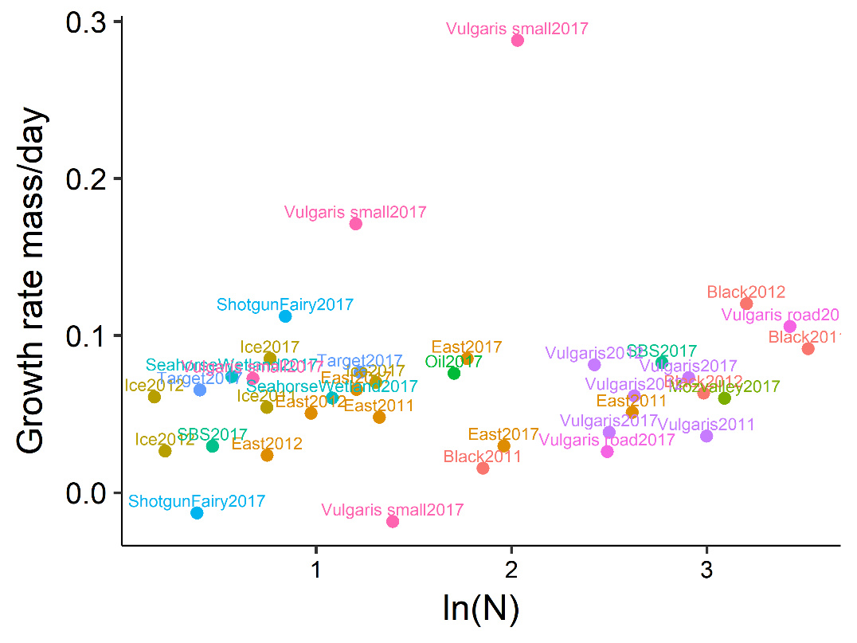

**PREDATORS**

1. **Are the places with the most # beetles consistent across years?**
   * Used avg beetle densities across dates after beetles started showing up in ponds

**Maybe. But again, 2012 lowest abundance in all cases.**

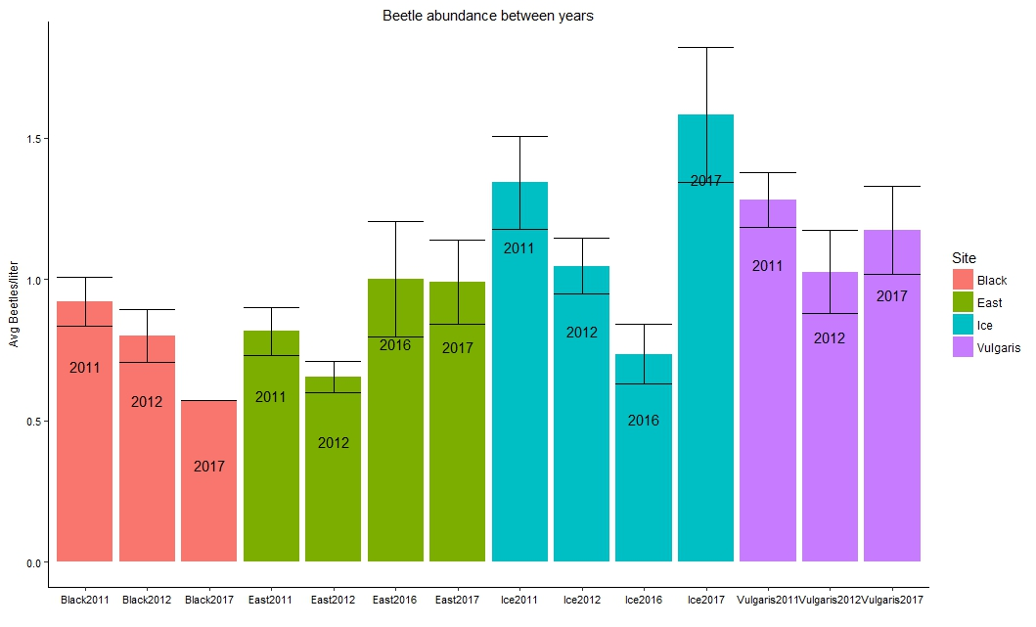

1. **Do ponds with higher densities of early instar mosquitoes have more beetle predators?**
   * Densities early instars @ first sampling (before there are beetles) vs. avg density of beetles

**Interesting! No relationship across ponds, but within ponds, in years with more mosquitoes there are more predators**

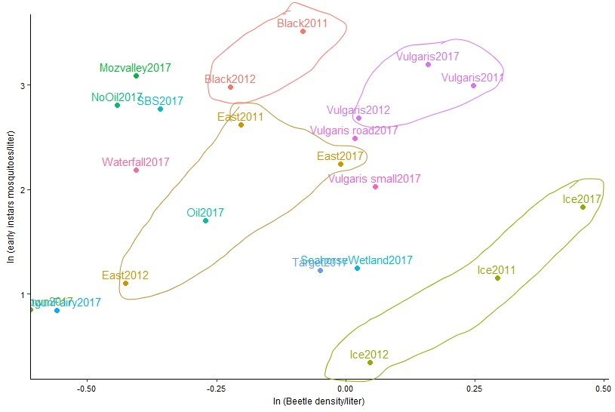

1. **Do ponds with greater densities of predators have fewer emerging mosquitoes?**
   * Avg predator densities vs. cumulative # from emergence traps

**No. Predator abundance in pond alone does not affect density of emerging mosquitoes**

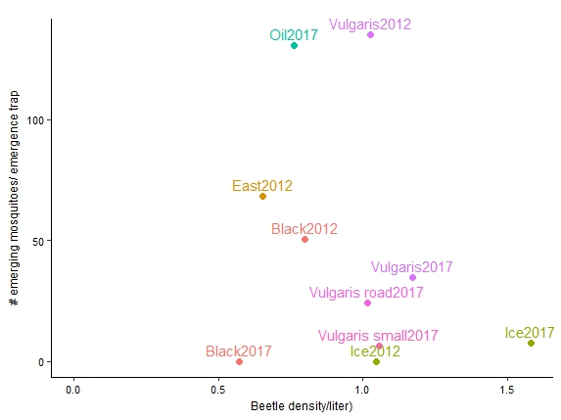

FOOD/RESOURCE (for now I used DOC as independent variable, but next year use a better metric)

1. **Do ponds with more DOC have more emerging mosquitoes?**

**Yes/maybe? Here I have made an assumption that DOC measure in 2017 was the same as DOC in 2012 for the same ponds…**

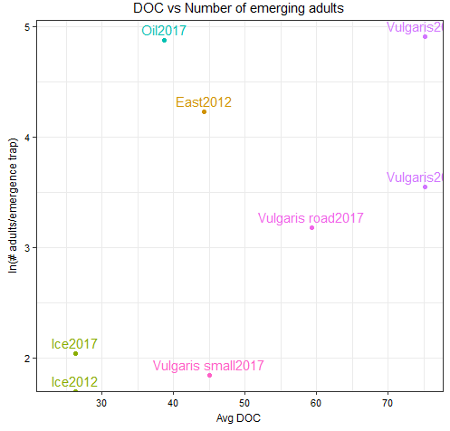

1. **Do ponds with more DOC have larger emerging mosquitoes?**

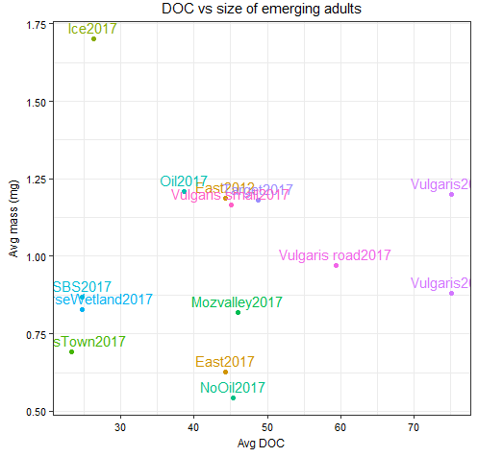

Temperature/Timing

1. **Do more mosquitoes emerge from warmer ponds?**

**Doesn’t seem like that. (but avg temp probably not the best metric)**

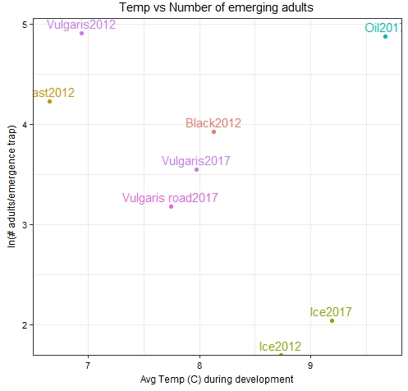

1. **Do mosquitoes emerge earlier in warmer ponds**

**Hard to tell from this because I plotted avg temperature in the ponds during larval development when I should probably use something like thermal sums.**

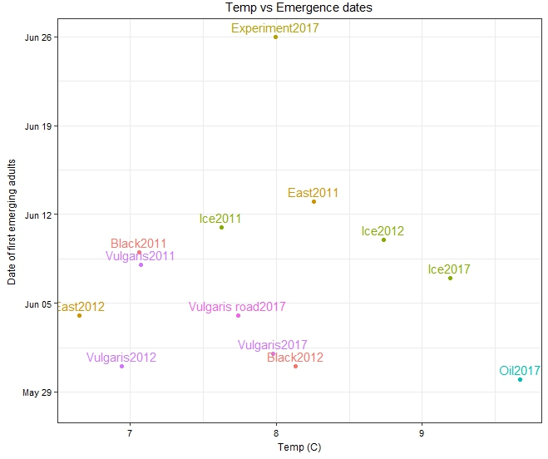

1. **Do mosquitoes grow more in warmer ponds**
   * **No obvious relationship when working with Growth rate (Δ mass/ Δ time)**

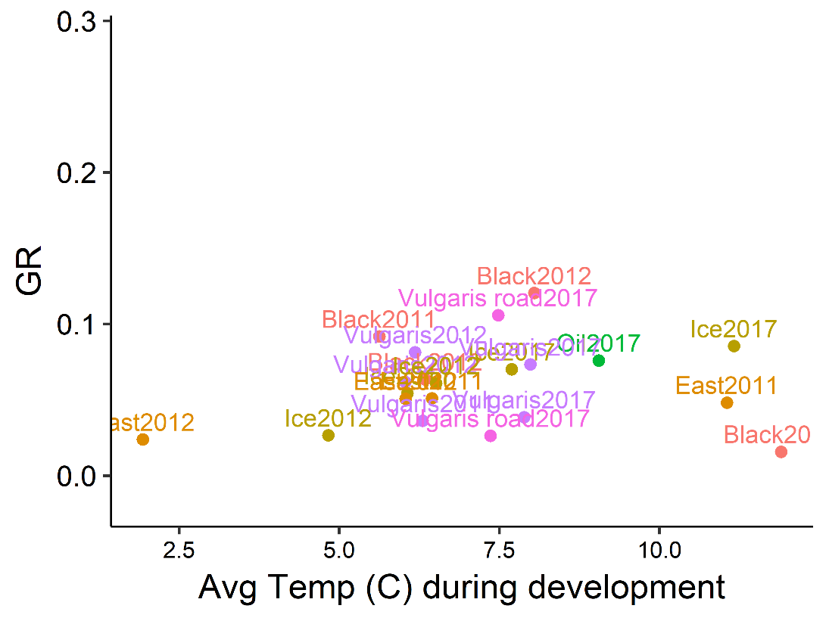

**Should be RELATIVE growth rate on Y. Plotted residuals from RGR vs. ln Mass. When you plot those residuals, there is a positive relationship with temperature (mosquitoes grow faster in warmer ponds)**

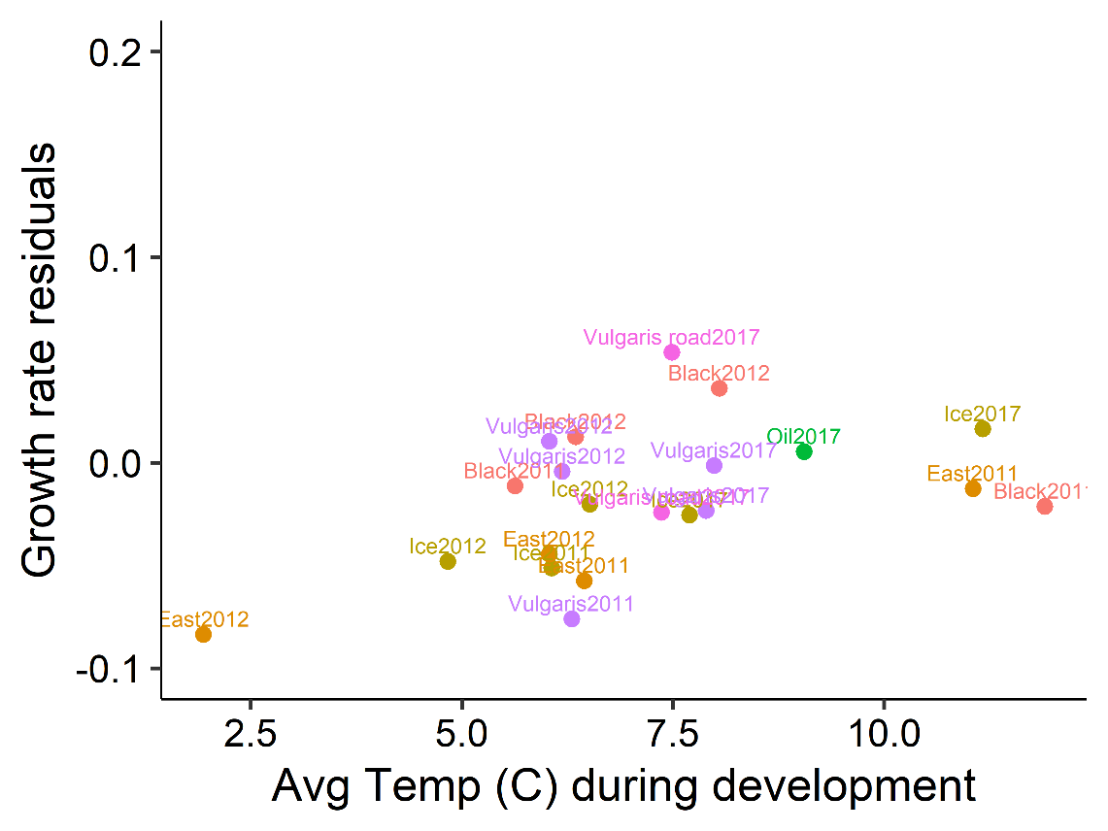

1. **Are mosquitoes that emerged earlier bigger?**
   * **No the opposite. Ones that emerged later are bigger**

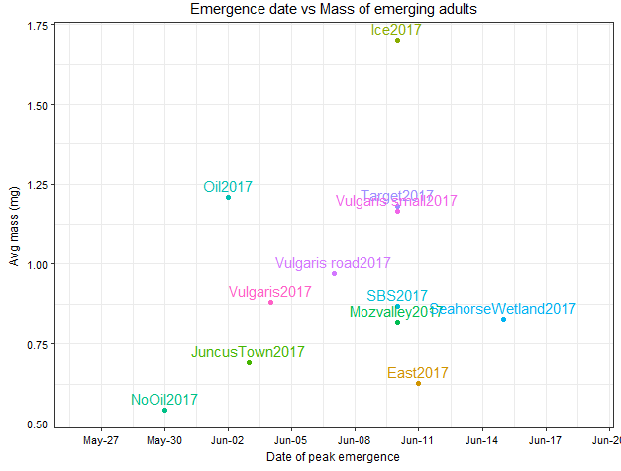

1. **Are mosquitoes that emerged in warmer temperatures?**
   * **Maybe? Not a lot of data, also avg temp is probably not the best metric**

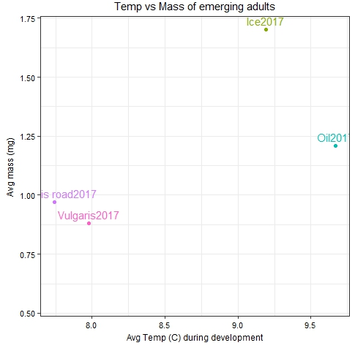

Remaining questions….Densities/Size

1. **Do ponds with more larval mosquitoes have smaller emerging mosquitoes?**
2. **Do ponds with higher per-capita mortality rates have fewer emerging mosquitoes?**
3. **Do ponds with higher per-capita mortality rates have smaller emerging mosquitoes?**
4. **Assuming constant DOC over the larval period, is there a relationship between per-capita mortality and DOC/density?**

Remaining questions….Predators

1. **How does per capita mortality change before and after predators**

Remaining questions….Temperatre/Timing

1. **Do beetles occur earlier in warmer ponds?**
2. **Do colder ponds have more days where mosquitoes and beetles overlap?**

**.**

**Adults/Eggs**

1. **What is the relationship between mass and wing length?**

**Nice power function. Wing length is usually easier to measure, and now that we know the function we can easily go from wing length to mass**

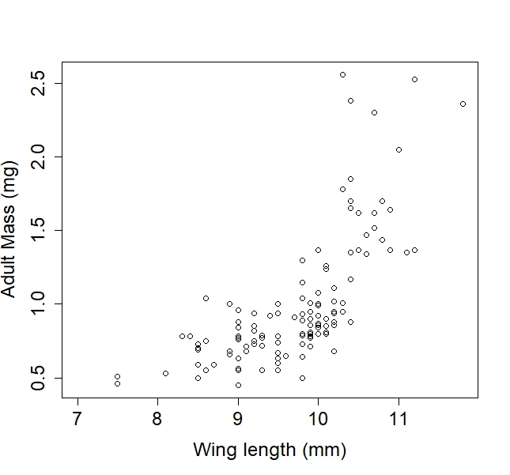

1. **What is the relationship between mass and egg #**

**Nice power function. Note the 2017 females were smaller. Also points with low egg numbers could be autogenous females or females that did not receive full blood meal.**

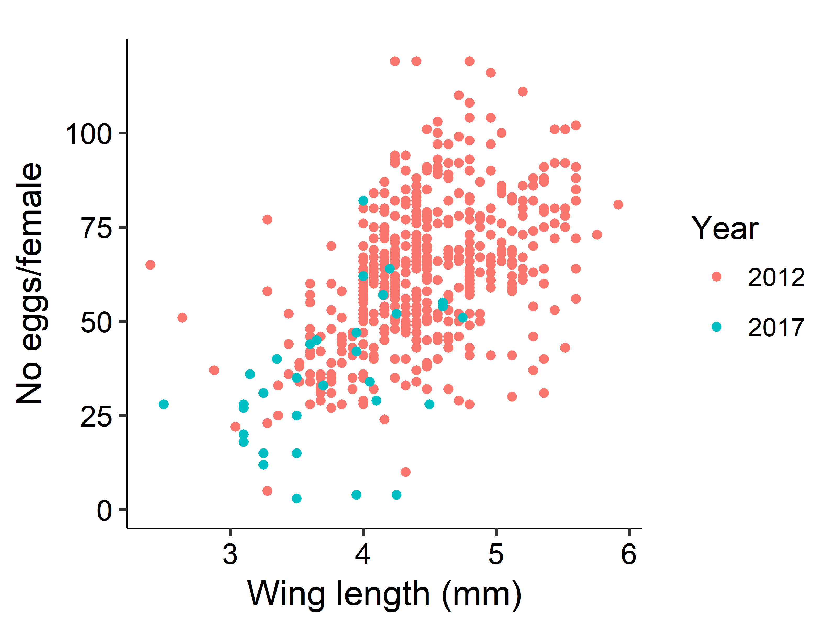

1. **Does size differ between male and female adults?**

**Not really. Females have slightly larger variance.**

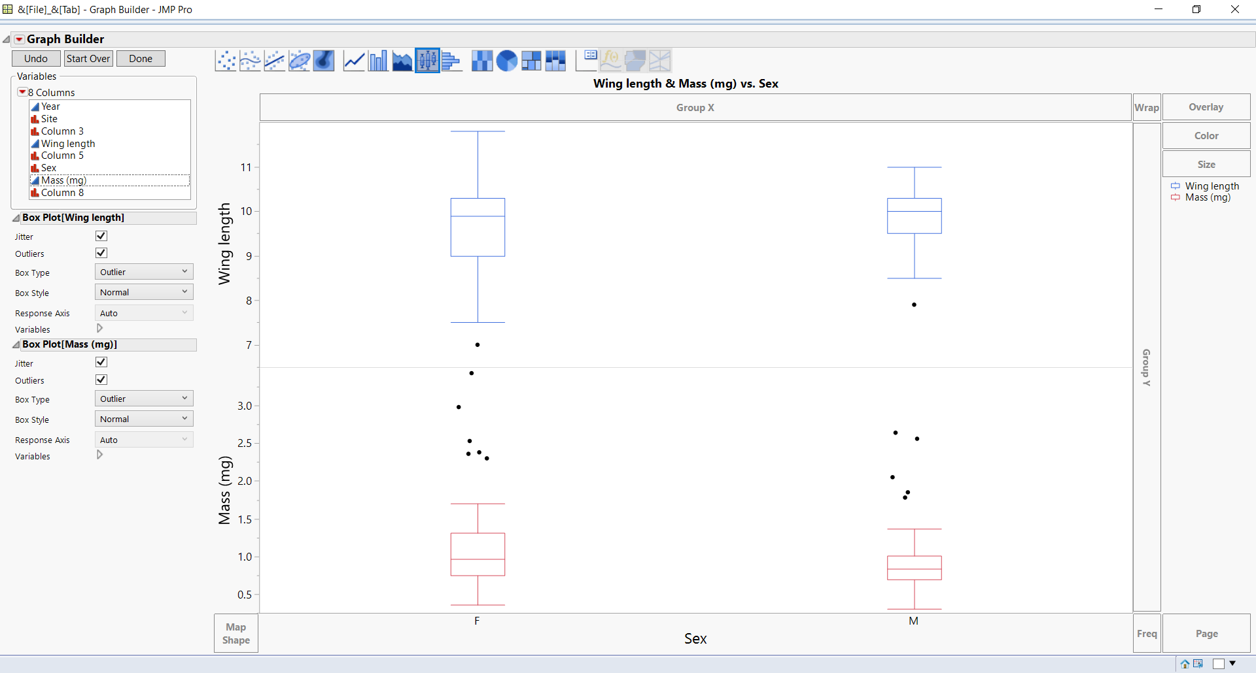

1. **Do sex ratios vary between ponds?**

**Yes. Average sex ratio is about 1.7F to 1 M.**

|  |  |  |  |  |
| --- | --- | --- | --- | --- |
| **SiteYear** | **Males/trap** | **Females/trap** | **Total/trap** | **F:M ratio** |
| 2012Black | 4 | 46.5 | 50.5 | 11.625 |
| 2012East | 43.5 | 25 | 68.5 | 0.574713 |
| 2012Vulgaris | 64.5 | 70.5 | 135 | 1.093023 |
| 2012Ice | 0 | 0 | 0 |  |
| 2017East | 1 | 1.333333333 | 2.333333 | 1.333333 |
| 2017Ice | 2 | 5.666666667 | 7.666667 | 2.833333 |
| 2017Oil | 28.33333333 | 102.3333333 | 130.6667 | 3.611765 |
| 2017Vulgaris | 18.33333333 | 16.33333333 | 34.66667 | 0.890909 |
| 2017Vulgaris road | 6.333333333 | 17.66666667 | 24 | 2.789474 |
| 2017Vulgaris small | 2.333333333 | 4 | 6.333333 | 1.714286 |
| **All** | **170.3333333** | **289.3333333** | **459.6667** | **1.69863** |